Chapter 13, Problem 63.

Find the mesh currents in the circuit of Fig. 13.128 below.

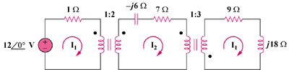

Figure 13.128
For Prob. 13.63.

